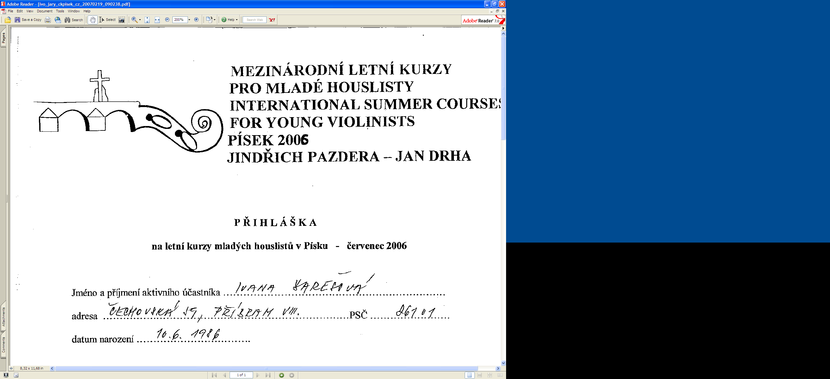
MEZINÁRODNÍ LETNÍ KURZY
PROF. OTAKARA ŠEVČÍKA
PRO MLADÉ HOUSLISTY,
XXXIX. ročník
INTERNATIONAL SUMMER COURSES PROF. OTAKAR ŠEVČÍK FOR YOUNG VIOLINISTS, XXXIX. ANNUAL, PÍSEK 2026
Prof. JINDŘICH PAZDERA / MgA. JAN DRHA

REGISTRATION
for summer courses of young violinists in Písek July 1 – July 13th 2026

You can send registration with signature through e-mail until April 30th 2026.
Send the registration to the e-mail address - divadlo@centrumkultury.cz.

Price of course – 1000 CZK (passive participation) / 3 000 CZK (half of course) / 4 500 CZK (complete course)
The participant's companion does not pay the course fee.
We will send you the invoice during May. After that, you will be able to pay for the course and, if necessary, accommodation
Name and surname:
Date of birth:
Address, country:
E-mail:
Telephone:
I will attend as: | active participant – passive participant
The companion (no course fee) | YES – NO  Name and surname of the companion:
Pedagogue: | Prof. Jindřich PAZDERA – MgA. Jan DRHA
Course length:

In…………………… on…………………
…………………………………………………… participant's signature, the underage participant must have the parent's signature and pedagogue consent. By signing I agree to the processing of personal data (Law 101/2000 Collection of law).

